PHYSICS 2APHY and 2BPHY

Formulae and constants sheet


Reproduced with the permission
of the Curriculum Council

Physics 2A/2B: Formulae and constants sheet

Forces and motion
Mean velocity | 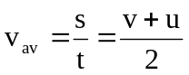
Equations of motion | 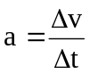 ; 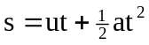 ; 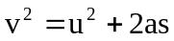; 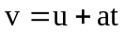
Force | 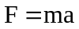
Weight force | 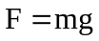
Momentum | 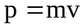
Change in momentum (impulse) | 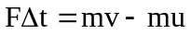
Kinetic energy | 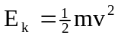
Gravitational potential energy | 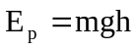
Work done | 
Power | 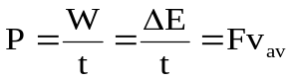

Particles
Energy of photon | 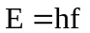
Activity | 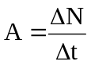
Half-life | 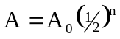
Absorbed radiation dose | 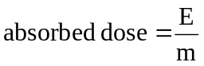
Dose equivalent
Mass-energy relationship | 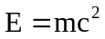
Change of temperature | 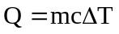
Change of state | 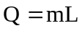
Absolute zero of temperature | 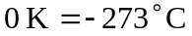
Electricity and magnetism
Electric current | 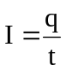
Electric field | 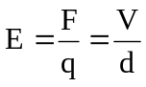
Work and energy | 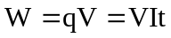
Ohm’s law | 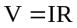
Resistances in series | 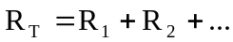
Resistances in parallel | 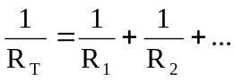
Power | 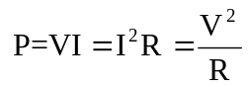

Physical constants
Speed of light in vacuum or air c = 3.00 x 10⁸ m s⁻¹
Electron charge e = -1.60 x 10⁻¹⁹ C
Electron volt 1 eV = 1.60 x 10⁻¹⁹ J
Unified atomic mass unit 1 u = 1.66 x 10⁻²⁷ kg
Mass of electron m_{e} = 9.11 x 10⁻³¹ kg
Mass of proton m_{p} = 1.67 x 10⁻²⁷ kg
Mass of neutron m_{n} = 1.68 x 10⁻²⁷ kg
Mass of alpha m_{α} = 6.65 x 10⁻²⁷ kg
Mass–energy equivalent 1 u = 931 MeV
Tonne 1 tonne = 10³ kg = 10⁶ g

Physical data
Mean acceleration due to gravity on Earth g = 9.80 m s⁻²

Quality factors
Approximate quality factor for alpha radiation QF_{α} = 20
Approximate quality factor for beta radiation QF_{β} = 1
Approximate quality factor for gamma radiation QF_{γ} = 1
Approximate quality factor for slow neutrons QF_{sn} = 3
Approximate quality factor for fast neutrons QF_{fn} = 10
Prefixes of the metric system

Factor | Prefix | Symbol | Factor | Prefix | Symbol
10¹²  10⁹  10⁶  10³ | tera  giga  mega  kilo | T  G  M  k | 10⁻³  10⁻⁶  10⁻⁹  10⁻¹² | milli  micro  nano  pico | m  µ  n  p

Mathematical expressions
Given 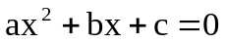, 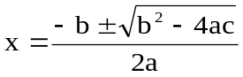

The following expressions apply to the triangle ABC as shown:  B  C  A  c  a  b | The following expressions apply to the right-angled triangle ABC as shown:  B  C  A  c  a  b
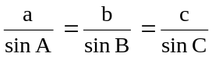 | 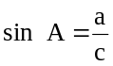
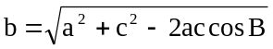 | 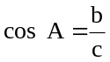
 | 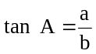

Electromagnetic spectrum

 |  | Wavelength
λ (m) |  |  |  |  |  |  |  |  |  | 10² |  |  |  | 10 |  |  |  |  |  | 1 |  |  |  |  |  |  |  |  |  | 10⁻¹ |  |  |  | 10⁻² |  |  |  | 10⁻³ |  |  |  |  |  | 10⁻⁴ |  |  |  | 10⁻⁵ |  |  |  | 10⁻⁶ |  |  |  | 10⁻⁷ |  |  |  |  |  |  |  | 10⁻⁸ |  |  |  |  | 10⁻⁹ |  |  |  |  | 10⁻¹⁰ |  |  |  |  | 10⁻¹¹ |  |  |  |  |  | 10⁻¹²
Area of  Spectrum |  |   microwaves  radio frequencies  infrared radiation  ultraviolet  radiation  X-rays  gamma rays
f(Hz) |  |  |  |  |  |  | 10⁶ |  |  |  |  |  | 10⁷ |  |  |  | 10⁸ |  |  |  |  |  |  |  |  |  |  |  | 10⁹ |  |  |  | 10¹⁰ |  |  |  | 10¹¹ |  |  |  |  |  | 10¹² |  |  |  | 10¹³ |  |  |  | 10¹⁴ |  |  |  | 10¹⁵ |  |  |  |  |  |  |  | 10¹⁶ |  |  |  | 10¹⁷ |  |  |  |  |  | 10¹⁸ |  |  |  |  | 10¹⁹ |  |  |  |  |  | 10²⁰
 | Frequency

Note: 1. Shaded areas represent regions of overlap.
2. Gamma rays and X-rays occupy a common region.

